Data Processing and Visualization (P02)

DECISION SUPPORT SYSTEMS, 2021-22

**João Fernandes (18825), Carlos Martins (18836)**

# Introduction

The goal of this project is the development of a data processing and visualization software solution, that provide us information about the data from Adventure works, such as: sales information, customers, products, etc.

In this project we have done data preparation, measures and columns that we thought necessary to perform the data presentation. These measures and columns were created so that we could create several dashboards in Power BI, since this allows us to show data in a better way.

# Data acquisition and preparation

In order to optimize the information that exists in the tables, we have cleaned some unnecessary data. Examples of such **data are those that are *"null****"*, **products that are unavailable**, photos that are **invalid**, **change values** in order to fetch external data. Here are some examples of what has been done:

Remove products with category *"null":*

Change “united states” to “United-States-Of-America” because of external flags:



# Data modelling and processing

To relate tables and be able to show more useful information, measures and columns have been created. We will now talk about each of them:

This measure is used to search for the most purchased product and shows the name of that product.



*“DISTINCTCOUNT”* was used to count the number of customers and of products without repeating them. This will tell us the total number of customers and products.



This measure indicates the average number of orders placed by customers, basically the average price spent by customers on orders.



The average price of the products is shown from this measure.



Shows the total sales for the year prior to a date.



This measure shows the most sold product and the total sales of that same product. We use it to know this in each region.



Here the total sales made by both internet and resellers are calculated. And it is also calculated the Variance in percentage per month of sales to know if the following month had better sales than the previous one.



# Data visualization

As we can see in the image below, we have a general dashboard for Internet sales. This dashboard has some **cards** with values and information that we think are important in these sales, such as the total value of sales, the bestselling product, the total number of customers, and an average of the amount spent on each order. Some of the measures mentioned above were used for these cards.

The **pie chart** shows the total sales in each country, and a **tooltip** that has information about the total sales of the previous and current year selected, and an **area chart** that shows the total sales per month. On the **clustered column chart**, we have the sales per month, we also added a **tooltip** on that chart to know which category was the most sold in that month.

In one **table** we show the total amount of sales per category, in the other we show the variance in percentage per month of sales to know if the following month had better sales than the previous one.

To filter by year and category, the information given in the dashboard, we added two **slicers**.

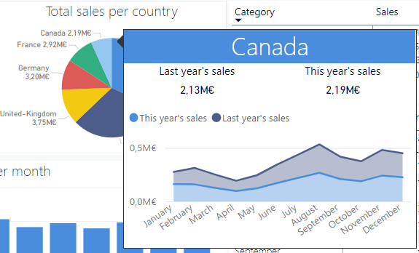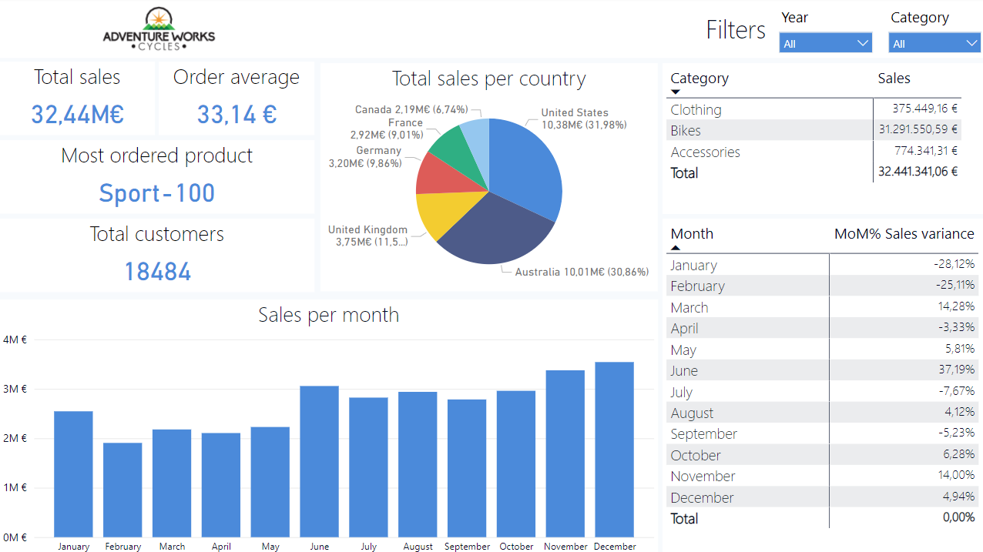

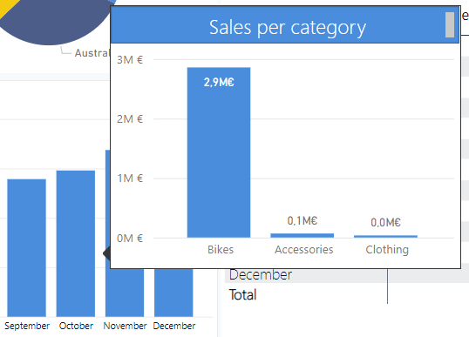

This dashboard shows a customer sales report, where we can see information about sales by customers.

We have a **card** that indicates the total number of customers. A **table** that shows the list of customers and the amount already spent by each one. A **funnel** that indicates the top 10 customers, the first customer being the one who spent the most, and so on.

We added four **slicers** that filter by year, customer name, product category and country.

To show a customer purchase history we used a **multi-row card**, to see the orders of each customer.

Finally, a **pie chart** that shows the number of customers for each category.

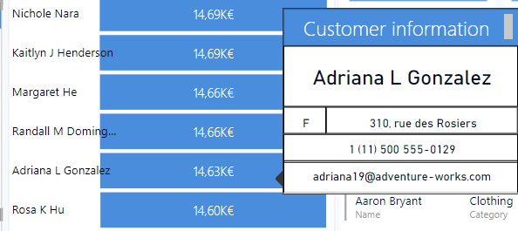

# Conclusion

With the completion of this work, we have gained a better understanding of what can be done when analytical processing and data visualisation is required and how this will be useful in future projects. When put into practice we have a much greater notion of what can be done at a professional level.